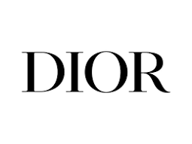

**SAUVAGE**

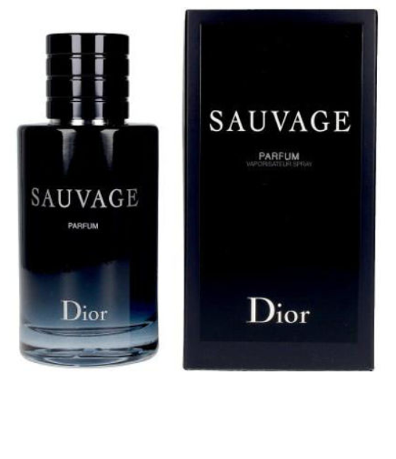This holiday season, give your loved ones the Sauvage gift set, featuring the eau de parfum inspired by the magic of the desert as night falls.  
  
The Sauvage fragrance set includes:  
  
- A Sauvage eau de parfum, 100 ml. Olfactory notes of Reggio di Calabrian Bergamot and Papua New Guinean Vanilla absolute.  
- A Sauvage fragrance miniature, 10 ml. A miniature eau de parfum, to take with you wherever you go.  
notes of Sauvage.